[**Topcoder ElasticSearch Feeder Service - Way To Populate Challenge-Detail Index For Legacy Marathon Matches v1.0**](https://apps.topcoder.com/forums/?module=Category&categoryID=43250) **Verification Guide**

# 

# Setup

For the feeder service, run 'mvn clean package' to compile the code and then cd local folder and run './run.sh' to start the services. Before starting the services, you need to first setup the environment as following sections.

The direct app docker is https://github.com/appirio-tech/tc-common-tutorials/tree/master/docker/direct-app

Please follow the above url to configure and setup the tc direct app docker.

For this challenge, you only need to start up the informix database by running:

docker-compose up tc-informix

If you want to push the data to the amazon elasticsearch service, please refer to Verification_Topcoder - Elasticsearch Feeder Service For Challenges version 1.0.docx.

For local ElasticSearch, you can use the ElasticSearch docker container in

https://github.com/appirio-tech/tc-common-tutorials/blob/master/docker/direct-app/docker-compose.yml.

Run 'docker-compose up elasticsearch' to start the service.

select the informixoltp database and run:

update round set forum_id = 111 where round_id = 13675;

delete from round_prize;

insert into round_prize values (13675, 1, 200);

insert into round_prize values (13675, 2, 100);

delete from round_registration;

insert into round_registration values (13675, 132456, current, 0, null);

insert into round_registration values (13675, 132458, current, 0, null);

delete from round_event;

insert into round_event values (13675, 1, 'event name 1', 'reg url 1');

insert into round_event values (13675, 2, 'event name 2', 'reg url 2');

delete from long_submission;

delete from long_component_state;

insert into long_component_state values (1, 13675, 132456, 2041, 99, 130, 2, 2);

insert into long_submission (long_component_state_id, submission_number, example, open_time, submit_time, submission_points) values (1, 2, 2, 132000, 1517544546857, 99);

delete from long_comp_result;

insert into long_comp_result (round_id, coder_id, placed) values (13675, 132456, 1);

delete from algo_rating where coder_id = 132456;

insert into algo_rating values (132456, 1000, 0, null, 0, 3, current);

# Verify

Import the docs/ mm-feeder-into-challenge-detail.postman_collection.json into the postman.

View MM to challenge detail via ElasticSearch with registrant and submitter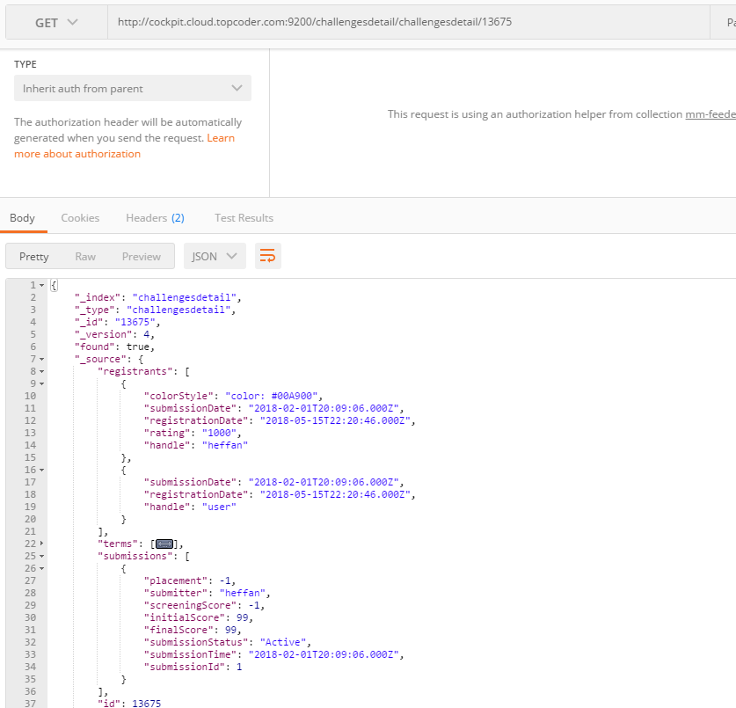

View MM to challenge listing via ElasticSearch without registrant and submitter

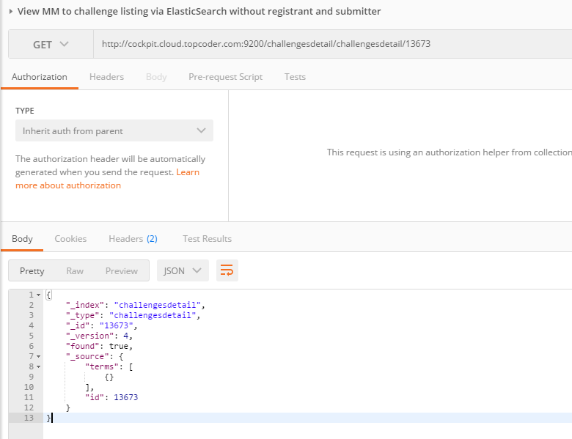

This challenge also refactors some common used methods from MmFeederManager to the util classes. Please refer to Verification_Topcoder - Populate Marathon Match Related Data Into Challenge Model In Elasticsearch v1.0 about how to verify the data in the elasticsearch

You can also check View MM to challenge model via ElasticSearch simply to make sure the data is loaded:

